PROPERTY ACQUISTION PROPOSAL
House and Mill, near Williamsburg Ontario
As of November 09, 2018
Property Address: | Near Williamsburg ON
Property Description & Opportunity Relevant Info.: | 4-Bedroom Custom Converted Carriage House and WoodWorking Barn/Mill. Severance of empty lot on west side of property possible.  Property zoned Residential. This is a recent change from Industrial to Residential. Property has a current environmental test and is sound.  Parking lot for 10 cars.  Located on the former primary route to Ottawa from Hwy 2, at the cross-roads of Bouck’s Hill, 5 minutes from Williamsburg.
Price: | $135,000
Appraisal | 2006 by Affiliate Appraisers for $300,000.
Market Value | 2018-19 $340,000
Zoning | R1
Buildings/Structures: | - Residential building. Originally a carriage house, converted by current owner into a 3-bedroom single-family dwelling that is to code.  - Commercial-Industrial building. Previously used as a woodworking mill.
Current Use | - Vacant house – can be rented for $950/mo plus utilities.  - Vacant commercial-industrial building – can be rented separately from house, or included in the house rental.
Proposed Use/Development: | Maintain the property as a rental with shop/business. Sever the back of the property and develop 4-unit multi-residential rental to hold, long-term. Asset value of this Armour Development real estate project is estimated at $750k (cost to build $600k).
Investment | $41,000 (for purchase down-payment and 1st mortgage through bank)  - 3 year term, at 12% ROI, paid at the end of the term.  - investor would be listed on title for the duration of the first mortgage, or until the refinance date (between 6 mo-1 yr).  - investor will net a cashflow from NOI, up to ~30% for the duration of the agreement  - Investor will retain 50% ownership of the property under a JV agreement.  - Ownership will convert to a majority owned by Armour at a future date at the end of the JV.
Cash-Flow Investment Strategy | Refinance the first mortgage after 6 mos – 1 year to unlock equity. This equity will be applied to:  a) repay up to 100% of investor(s) principal equity investment;  b) operationalize the mill/furniture/construction business on site;  c) soft development costs for the 4-plex severance, zoning, investor relations and design.
Cash Flow Projections | 3-Year Gross Cash-Flow Projections  Rents Year 1 Year 2 Year 3  House (3-bdrm) $11,400 $11,628 $11,860  4-Plex $48,000 $48,960 $49,939  Mill Rental $6,000 $6,120 $6,242  Annual Total $65,400 $66,708 $68,042  Annual *Mill Co. Total $50,000 $100,000 $150,000  Gross Cash-Flow $115,400 $166,708 $218,042

*Wood Mill, Construction Co. and Furniture Studio Business Strategy
The Mill would produce base board, trim and construction materials for large builders and the Furniture studio would build one of a kind pieces and sell these to larger client markets and online. Concepts https://www.pinterest.ca/johnmeharg/startuphouseca/
The Mill and Studio should generate an annual revenue of approx. $200k top line income per year by year 3. This would be divided by equity partners after operating expenses.

Aerial View of Property:
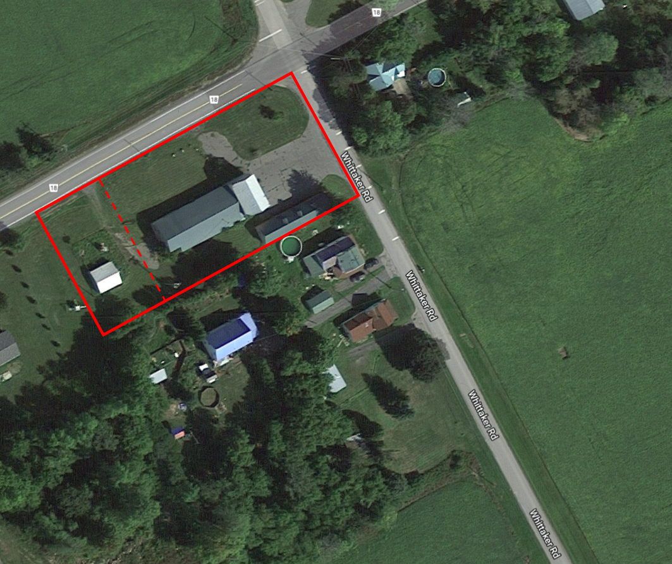

- Dotted line denotes area for possible residential property severance on the west side of the lot.

Property Location:
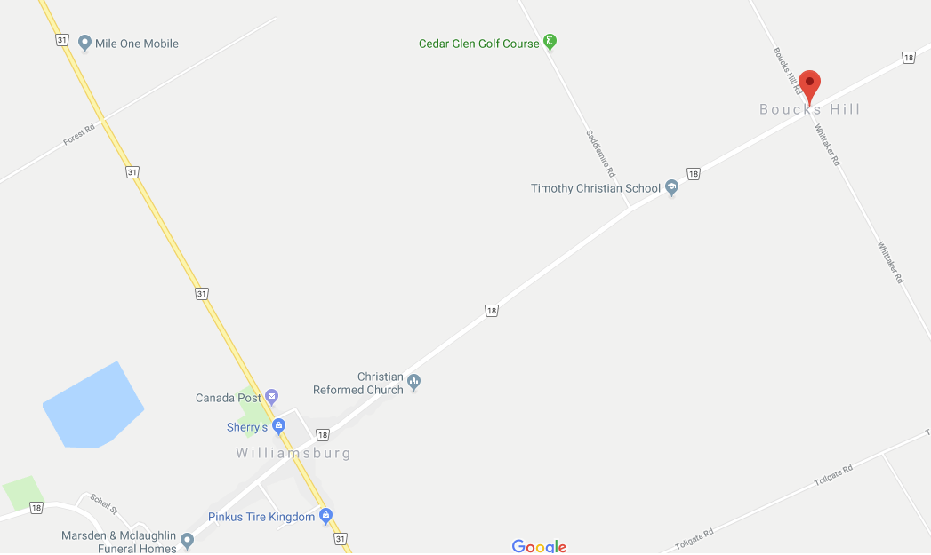

Site Photos
East View of Carriage House and Lumber Mill
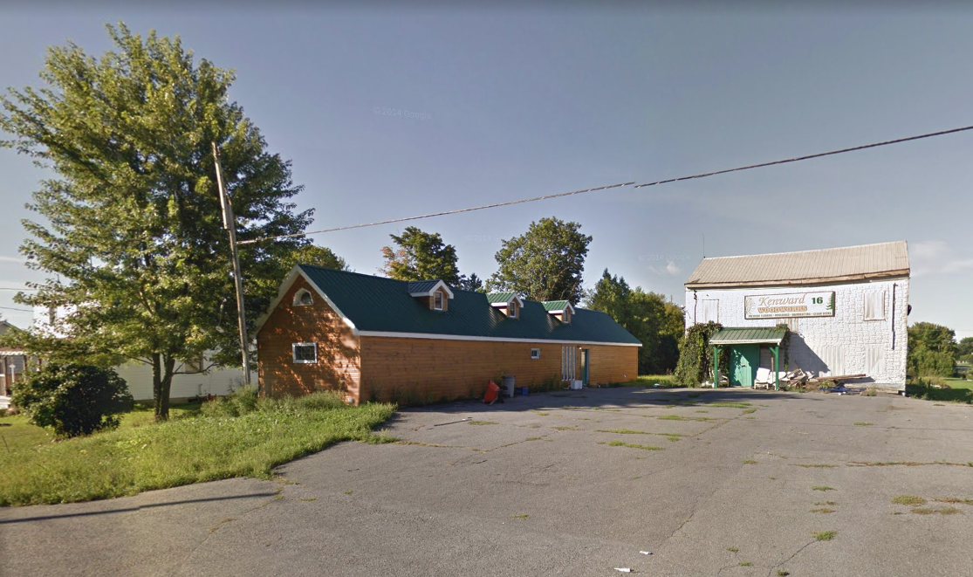

Houses to the South of the Carriage House
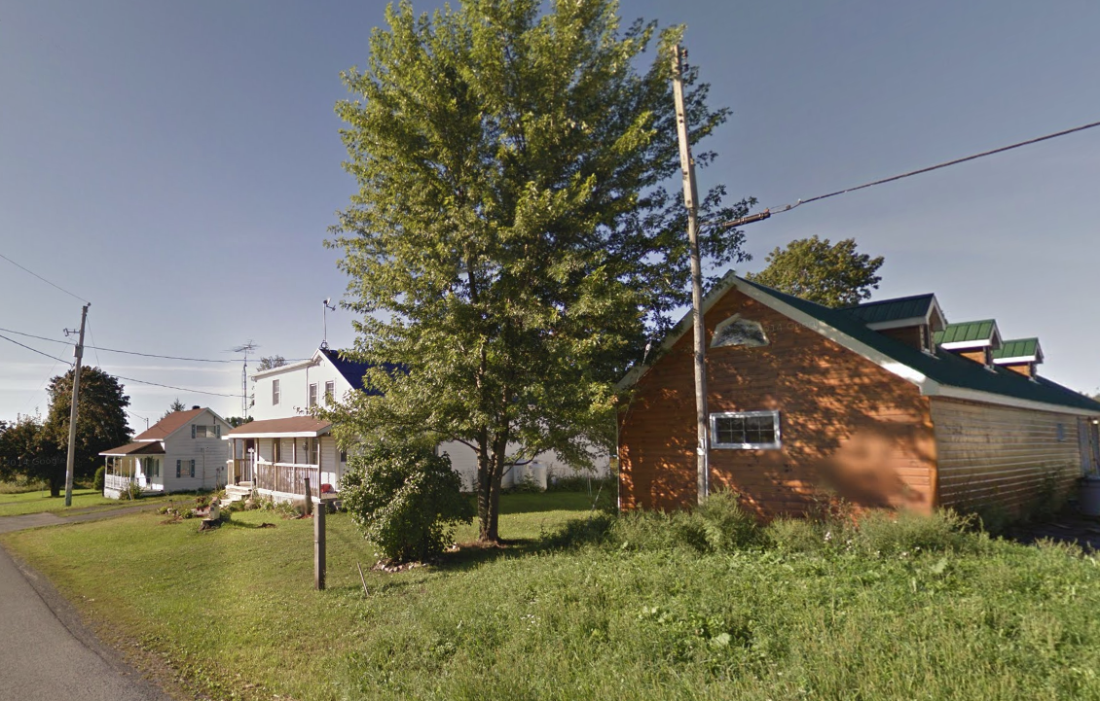

North View of Lumber Mill, right side of track possible for residential severance

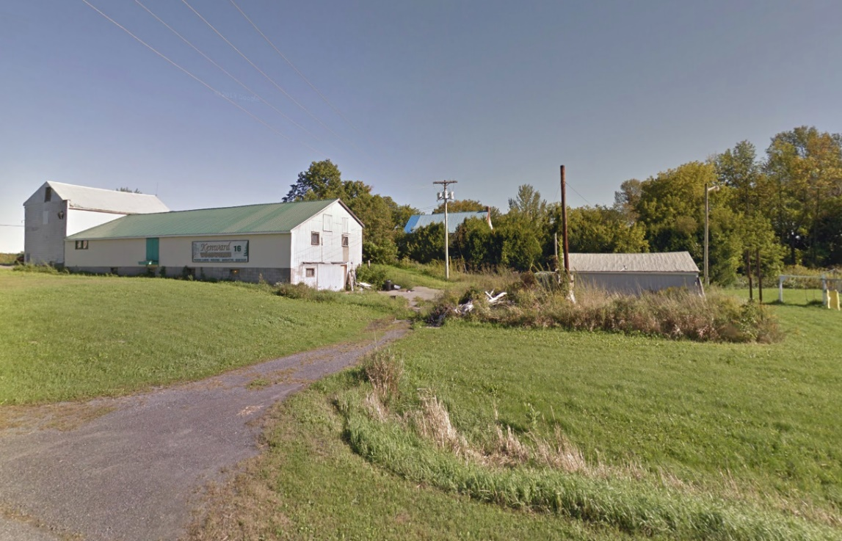

Mill and North-East Corner of Property
